Dioscaí Gréine / Pair of Gold Discs
Tedavnet, Co. Muineachán.  Cré umha Luath, 2200-2000 RC.  Leibhéal urlár – Músaem Náisiúnta na hÉireann  Ór - Ireland's Gold Exhibition  Fuaireas na dioscaí órga seo de gnáth, I bpéirí. Fuaireas an bheirt thall istigh I measc rúta crann.  Méid -Trástomhas 11.3 and 11.5cm;  Meachán 22.5 and 22.8 grams.  Meán  - Ór buailte i leathán tanaí. | 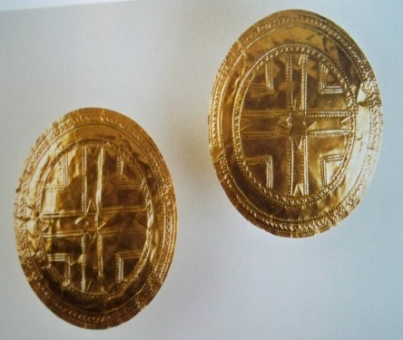
Foirm
- Tá cruth na dioscaí cosúil le cruth stíliúil teibí don ghrían..
- Tá na dioscaí piosa beag ardaithe mar duama san.

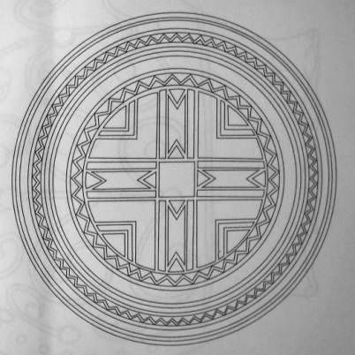
Maisiú
- Tá na dioscaí maisithe le motíf mór larnach crósach, Triantáin agus sraith poncanna ardaithe.
- Tá an motíf larnach don crós colbha le ciorcail comhlarnacha, zig zaganna, Triantáin Heateailte agus poncanna The central cruciform motif is surrounded by radiating concentric circles of zigzags, hatched triangles and dots.

Teicnic
- Bhí an cruth ciorcalach gearrtha ó leathan thanaí ór.
- Rinneadh an maisiú ag úsáid an modh repoussé agus pritíl The decoration is created by the metal working techniques of repoussé and punching.
- Repoussé is the term used to refer to when decoration was hammered into raised relief from the reverse (back) side of the metal.
- Pritíl / Punching is the term used when decoration was created by using a sharp pointed instrument to punch into the metal circular marks or dots.

Feidhm
- Tá dhá pholl beag san lár don dhá dhiosca. Ceaptar go raibh seo chun iad a cheangal do eadaí mar mhaisiú.

